Object Oriented Programming

What Is a Class?
Class is a structure and behavior of an object or group of objects.

What Is an Object?
OOP’s combines the user defined data and instruction into a single unit is called object. An object is said to be an instance of a class.
//class declaration
public class Student {
// Instance variables
int rollNo;
String name;
// set the detail
public void setDetail(int r, String n){
rollNo = r;
name = n;
}
// get the detail
public void getDetail() {
System.out.println("Roll No: " + rollNo);
System.out.println("Name: " + name);
}
}

//class object creation or class instantiation
import java.util.Scanner;
public class StudentMain {
public static void main(String[] args) {
int rollNo;
String name;
Scanner sc = new Scanner(System.in);

System.out.println("Enter roll number and name of 1st Student: ");
rollNo = sc.nextInt();
name = sc.next();

Student s1 = new Student(); // object creation
s1.setDetail(rollNo, name);
s1.getDetail();

System.out.println("Enter roll number and name of 2nd Student: ");
rollNo = sc.nextInt();
name = sc.next();

Student s2 = new Student(); // object creation
s2.setDetail(rollNo, name);
s2.getDetail();
}
}
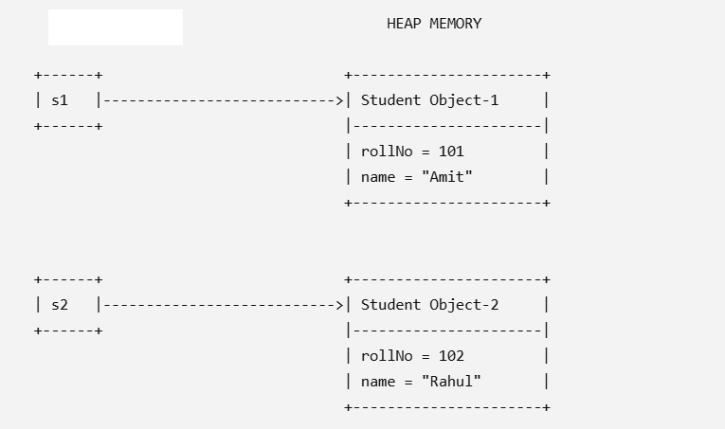

Key Points
- Student is a class (blueprint).
- s1 and s2 are reference variables stored in the stack.
- Objects created using new Student() are stored in the heap.
- Each object has its own copy of the instance variables (rollNo and name).
- Calling setDetail() stores values inside that specific object.
- Calling getDetail() reads values from the object referenced by s1 or s2.
- Changes made to s1 do not affect s2, because they refer to different objects in memory.

Note: Creating a class does not allocate memory for its instance variables. Memory for instance variables is allocated only when an object (instance) of the class is created.
Object display the following characteristic (properties):

State: Set of attribute and value of these attributes.
Behavior: Change of its state over a period of time.
Identity: Each object has unique identity.

Defining Classes
A class declaration introduces a new reference type. It has the following general syntax:
<class modifiers> class <class name><extends clause> <implements clause> //Class-header
{ //Class-body
<field declarations>
<method declarations>
<nested class declarations>
<constructor declarations>
<initializer blocks>
}

Class Variables
Instance variable | Static variable
1) Declared inside the class. | 1) Declared inside the class.
2) Created when the class instantiated. | 2) Created when the class is loaded at run-time.
3) Every object of the class has its own copies of these variables. Each object can have different value for these variables. | 3) Allocated memory only once but are globally accessible to all instance of the class. Each object/instance have same value for these variables; if any change occurs in static variable, they will be remain same for all of these objects/instances.
4) Exist as long as the object they belong to exist. | 4) Exist as long as the class exists.

// instance v/s static variable
class Var {
int a;
int b;
static int c;
public void set(int x, int y, int z){
a = x;
b = y;
c = z;
}
public void get(){
System.out.println(a+"\t"+b+"\t"+c);
}
}

class VarDemo {
public static void main (String args[]){
Var v1 = new Var();
v1.set(10,20,30);
v1.get();

Var v2 = new Var();
v2.set(100,200,300);
v2.get();

v1.get();

System.out.println(v1.a+"\t"+v1.b+"\t"+v1.c);
System.out.println(Var.c);
}
}
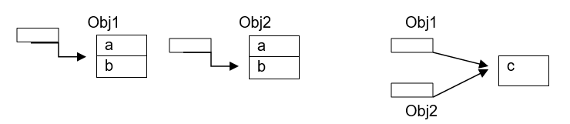
What is a Method?

A method in Java is a block of code that performs a specific task. Instead of writing the same code again and again, we write it once inside a method and call it whenever needed.

Real-Life Example

Power(int base, int expo) → To calculate the power
length(int value): To calculate the lenght of an integer value.

Advantages of Methods
Code reusability (Write Once, Use Many Times)
Easy to maintain and debug
Breaks a large program into small manageable parts

Syntax of Method Declaration

modifier returnType methodName(parameterList)throws Exception {
// method body
}

Example:

public void power(int base, int expo){
// Write operation to perform X raise to the power Y
}

Static v/s instance Method in java?
Instance
- Instance method is associated with the instance of the class and they will initialize after class instantiation.
- We can access instance method using the object of this class,
- Instance method is used to change the state of an object.
- We can access static and non-static member inside instance method.
- We can use of “this” inside instance method because instance block having an instance of class.

Static
- Static methods belong to the class rather than object of a class & will be initialize at the time of class loading.
- A static method can be invoked without the need for creating an instance of a class.
- Static method can access static data member and can change the value of it.
- The static method can not use non static data member or call non-static method directly. Because they have no instance of class.
- this and super cannot be used in static context. Because they have no instance of class.
- Static methods are used to create factory pattern and singleton Pattern in java.
Example 1:

class Demo{
int a = 10;
static int b = 20;
// instance method
public void instanceMethod(){
System.out.println(a); // Valid
System.out.println(b); // Valid
}
// static method
public static void staticMethod(){
System.out.println(a); // Invalid CT Error
System.out.println(b); // Valid
}
}

Example 2:
class Demo{
// instance method
public void instanceMethod(){
}
// static method
public static void staticMethod(){

}
}
class Main{
publci static void main(String args[]){
Demo d = new Demo();
d.instanceMethod();
d.staticMethod();

Demo.staticMethod();
}
}

Method Overloading
Each method has a signature, which comprises the name of the method and the types and order of the parameters in the formal parameter list. Several method implementations may have the same name, as long as the method signatures differ. This is called method overloading. Since overloaded methods have the same name, their parameter lists must be different.
Rather than inventing new method names, method overloading can be used when the same logical operation requires multiple implementations. The Java 2 SDK APIs make heavy use of method overloading. For example, the class java.lang.Math contains an overloaded method min(), which returns the minimum of two numeric values.
public static double min(double a, double b)
public static float min(float a, float b)
public static int min(int a, int b)
public static long min(long a, long b)
Method Overloading Is an example of compile time polymorphism. Each method has a signature, which comprises the name of the method and the type and order of the parameter in the formal parameter list. Several method implementations may have the same name, as long as the method signature differ. This is called method overloading. Since overloaded method have the same name, their parameter lists must be different.
Access-specifier return-type method-name(arg1,arg2………)

nature of method
Example1:
class MethodOverloding{
public int sum(int a, int b){
return a+b;
}
public long sum(long a, long b){
return a+b;
}
public float sum(float a, float b){
return a+b;
}
public double sum(double a, double b){
return a+b;
}
}

class MethodOverlodingExample{
public static void main(String args[]){
MethodOverloding obj = new MethodOverloding();

byte a1 = 10, b1 = 20, c1;
c1 = (byte)obj.sum(a1, b1);
System.out.println(c1);

short a2 = 10, b2 = 20, c2;
c2 = (short)obj.sum(a2, b2);
System.out.println(c2);

int a3 = 10, b3 = 20, c3;
c3 = obj.sum(a3, b3);
System.out.println(c3);

long a4 = 10, b4 = 20, c4;
c4 = obj.sum(a4, b4);
System.out.println(c4);

float a5 = 10.0f, b5 = 20.0f, c5;
c5 = obj.sum(a5, b5);
System.out.println(c5);
double a6 = 10.0, b6 = 20.0, c6;
c6 = obj.sum(a6, b6);
System.out.println(c6);
}
}

Example 2:

class MethodOverloadingDemo {
public void display(int a, long b) {
System.out.println("Method with (int, long) parameters");
System.out.println("a = " + a + ", b = " + b);
}
Public void display(long a, int b) {
System.out.println("Method with (long, int) parameters");
System.out.println("a = " + a + ", b = " + b);
}
public static void main(String[] args) {
MethodOverloadingDemo obj = new MethodOverloadingDemo();
obj.display(10, 20L); // Calls display(int, long)
obj.display(30L, 40); // Calls display(long, int)
}
}

Important Note

The following call is ambiguous and results in a compile-time error:
obj.display(10, 20);

First method
display(int, long)
- 10 → int ✅ Exact match
- 20 → int can be automatically converted to long ✅
So this method is applicable.

Second method
display(long, int)
- 10 → int can be automatically converted to long ✅
- 20 → int ✅ Exact match
This method is also applicable.

Why does Java give an error?
Both methods are equally good:
- In the first method, the second parameter needs conversion (int → long).
- In the second method, the first parameter needs conversion (int → long).
Neither method is better than the other, so the compiler gets confused.
Both are equally qualified, so neither knows who should come.

Use Case of Static Method:

If a class does not have any instance variables (attributes), then its objects do not maintain any state. Such a class is called a stateless class. In this case, the methods usually do not need an object to execute, so they can be declared as static.

class MathUtility {
static int add(int a, int b) {
return a + b;
}
static int subtract(int a, int b) {
return a - b;
}
static int multiply(int a, int b) {
return a * b;
}
static int devide(int a, int b) {
return a / b;
}

}

public class Main {
public static void main(String[] args) {

int sum = MathUtility.add(20, 10);
int difference = MathUtility.subtract(20, 10);

System.out.println("Sum = " + sum);
System.out.println("Product = " + product);
}
}

Use Case of Instance Method:

If we want to access or change the state (data) of an object, we must use an instance method because it operates on a specific object.

class BankAccount {
int accNumber;
String name;
int balance;
public BankAccount(int accNumber, String name, int balance){
this.accNumber = accNumber;
this.name = name;
this.balance = balance
}
public void deposit(double amount) {
balance = balance + amount; // changes object state
}
public void withdraw(double amount) {
balance = balance - amount; // changes object state
}

public void displayBalance() {
System.out.println("Balance = " + balance);
}
}

public class Main {
public static void main(String[] args) {
BankAccount account = new BankAccount(1000);
account.displayBalance(); // Balance = 1000.0

account.deposit(500);
account.displayBalance(); // Balance = 1500.0

account.withdraw(300);
account.displayBalance(); // Balance = 1200.0
}
}

